**Certificate of Participation**

**Recognizing**

***[your company name]***

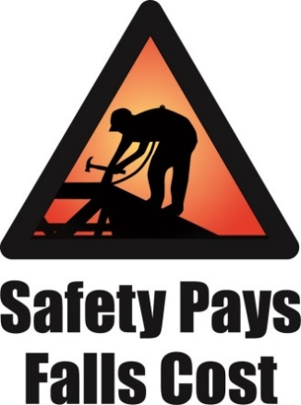**for taking part in the**

Date**

Craig Blackwood, Assistant Director

Division of Occupational Safety and Health

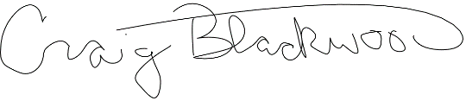

*May 2024*

**2024 Safety Stand-Down**

**to Prevent Falls in Construction**