HINT: To skip to the section you want, place your curser over the Content name and press Ctrl+Click.

Contents
Introduction 2
Is this the right Guide for me? 2
How can this Billing Guide help me? 2
What are L&I training benefits? 2
Things to be aware of: 3
What is an Encumbrance Form? 3
What is it used for? 3
What is on it? 3
Let’s break it down 5
How to Bill L&I 7
What information do I need before I can bill? 7
What date(s) should I use for the “From/To Dates of Service? 7
How much can I bill? 7
Billing Codes 7
Example 8
How do I submit a bill? 10
Electronic 10
Paper 11
How do I get paid? 12
Choose direct deposit or mail 12
When do bills process? 12
How do I find out what has been paid? 12
What if I need to re-submit a bill? 13
What if I have billing questions? 13
VRC 13
L&I websites 13
Provider Hotline (PHL) 13
School Oversight Program 13
Glossary 13

Introduction
This Guide contains step-by-step instructions and resources to help you bill L&I for training services.

Is this the right Guide for me?
Use this guide if:
- You have an active L&I Provider number and are designated as a school or training facility.
- Your student has Option 1 training benefits. You should have an approved Encumbrance Form for this student showing dollar limits, date spans, and identifying the training provider(s). If you do not have an Encumbrance Form, contact the Vocational Rehabilitation Counselor (VRC) or the student.
This is not the guide for you if:
- You do not have an L&I Provider number. To become a provider, go to Become a Training Provider.
- Your student has Option 2 training benefits with an Authorization Letter. See the Billing Guide for Option 2 Training Providers.
- Your student has a self-insured claim. Contact the self-insured employer for their billing and payment process. If you’re unsure if the claim is self-insured, contact your student or their VRC.

How can this Billing Guide help me?
L&I has specific billing procedures, codes and forms. It will be easier for you to submit your bills and get paid when you understand what L&I needs. This Guide also has web links and other resources to answer your questions and get assistance.

What are L&I training benefits?
Washington State Department of Labor & Industries (L&I) administers worker’s compensation benefits. Some workers who were injured on the job may qualify for retraining benefits. When this occurs, a VRC will develop a retraining plan with the worker and submit the plan.
If L&I approves the plan, the worker has two options:
- Option 1: The worker chooses to follow the approved L&I retraining plan and continues working with the VRC. The plan can be up to 2 years and has limited training funds.
- Option 2: The worker chooses their own training path. L&I authorizes limited funds they can use at any L&I approved training provider within five years. A worker may, or may not, choose to have Vocational Rehabilitation Counselor (VRC) assist them.

Things to be aware of:
- Do not bill the student or the VRC for tuition. L&I cannot reimburse them.
- Do not bill more than you would any other student for the same program.
- Refer to the School Billing Policy for specific requirements.
- Changes to a billing address or tax identifier could require a different provider number and could cause bills to be delayed or denied. If this situation arises, please email SchoolOversightProgram@Lni.wa.gov.

Encumbrance Form
L&I uses this form to decide whether to pay, adjust or deny a bill submitted by a school. Payment may be adjusted or denied if dates or amounts do not match information on the form.
There are two encumbrance forms for different purposes:
- Plan Time/Cost/Travel Encumbrance – This is the primary form used by schools. It shows training site(s), dates of service, and approved expenditures. It documents training site(s), dates of service, and approved expenditures. It is created by the Vocational Rehabilitation Counselor (VRC) and must be authorized by L&I. The VRC is responsible to give each school a complete and accurate Encumbrance Form. Schools should verify the information is correct. If you have questions or notice inaccuracies, contact the VRC.
- Plan Room and Board Cost Encumbrance – Schools that provide housing for the worker may need this form. Contact the VRC if you have questions.

What is on it?
Here is a sample Plan Time/Cost/Travel Encumbrance form:
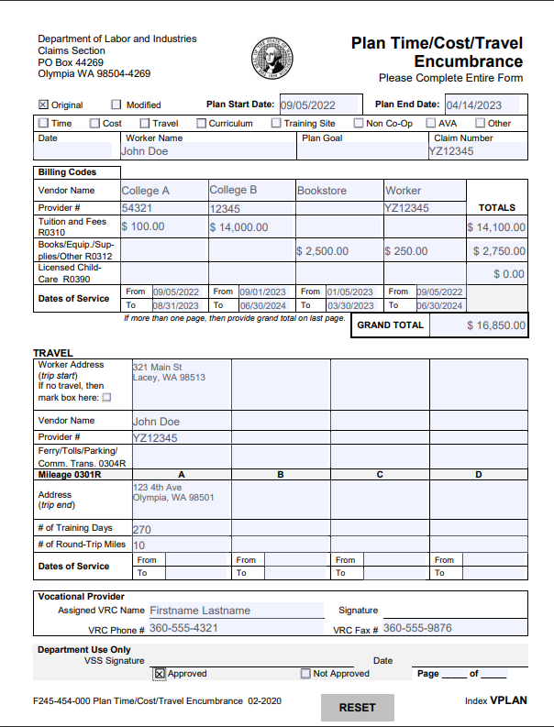

Let’s break it down:
- Original is the first approved plan.
- Modified indicates the plan has been updated. The VRC should give you this form any time there are changes to the plan. Please take note if any of the boxes below are checked, such as Time, Cost, etc. Each checked box indicates a change to the original encumbrance form. These are the new billing parameters. Schools should update their billing documents as needed.
- Plan Start Date is the approved beginning of any training.
- Plan End Date is the approved end of all training.
- Date - When the Encumbrance form was created.
- Worker Name – This should match the name of the student you are billing for.
- Plan Goal – This should align with your training program, either directly or in support of the goal.
- Claim Number – This is assigned when L&I accepts a worker’s claim they were injured on the job. A worker may have more than one claim number. The number(s) must be on the bill form in order for L&I to pay you for your services.
- Billing Codes – This section is critical for accurate billing. It identifies each vendor (provider) and the maximum amount L&I will pay, by billing type (e.g. Tuition and Fees, Code R0310).
  - Vendor Name – You will see your business name and your L&I Provider Account number. You may also see other entities authorized to bill L&I, such as another school or the worker.
  - Provider # - Your official L&I Provider Number should be under your business name. This is the number attached to your Provider Account and is the basis for tracking and paying bills. This number must be on the bill form in order for L&I to pay you for services.
  - Tuition and Fees (R0310) – Find the column with your Provider Name and the relevant Dates of Service. Use code R0310 when you submit your bill for tuition and fees.
  - Books/Equip/Supplies/Other (R0312) – Use the code R0312 to bill L&I for items necessary for the worker to complete your training program.
  - Licensed Child-Care (R0390) - You may use this code if your L&I Provider Account identifies you as a Licensed Child Care provider.
- Dates of Service: From and To – Bills submitted to L&I must be within these dates and must not exceed the total dollar amount listed. The dates under your provider name should match the time period the worker will be attending your training.
- The authorized amounts and dates are the basis for L&I’s ability to pay you. Refer to them when you bill for services.

- Travel – This section of the form is used to reimburse workers for travel. Please contact the worker’s VRC if you have questions about travel expenses.

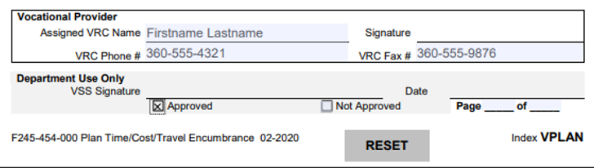
- Assigned VRC Name – The assigned Vocational Rehabilitation Counselor (VRC) is responsible for assisting the worker in returning to work. This is your primary contact during the training program.
- VSS Signature – An L&I Vocational Services Specialist (VSS) reviews and authorizes the Encumbrance form submitted by the VRC. This signature allows L&I to pay the vendors listed on the form. It is also used to determine if the amount billed is within the authorized limits for the worker’s training plan.

How to Bill L&I

What information do I need before I can bill?
- L&I Provider Name and Account Number.
- The authorized L&I Encumbrance form.

What date(s) should I use for the “From/To Dates of Service?
  - Rely on the Encumbrance Form. Date(s) must be within the dates listed on the Encumbrance form in order to prevent denials, adjustments and delays.
  - You can enter the first date of the quarter/semester for both the “From Date of Service” and the “To Date of Service” box. You do not need to enter different dates for these boxes (“date span”) on the billing form.

How much can I bill?
- You cannot charge L&I more than you would any other student for the same program.
- Billing must match the Encumbrance form. Tuition is generally by quarter, semester or in 90-day increments. Private schools should split bills into no more than 90-day increments.
- If the student’s training ends early, see the refund requirements in the billing policy.

Billing Codes
L&I uses Billing Codes to identify and track the different types of services we pay for. To help you bill correctly, you should rely on information in the Encumbrance form.
Note: The terms Procedure Code, Training Code, Retraining Code, and Billing Code are used interchangeably among billing forms.
The Encumbrance form lists three codes. In order for L&I to pay you for your services, you must enter the relevant code for your service(s) on the billing form.
Training Codes
R0310 | Tuition, Training Fees
R0312 | Supplies, Equipment, Tools, Books
R0390 | Child Care Services
- R0310 – Tuition and Fees. Use this code for tuition and fees, including licensing exam fees.
- R0312 - Books, equipment, and supplies. Use this code if you are paying directly for supplies the student needs, such as a computer or professional kits. You can also use this code if your business is a vendor for equipment or supplies the student needs, such as a books.
- R0390 - This is for daycare services. In order to use this code, you must have a specific Provider Account (Business Name and Provider Number) that designates you as a Child Care Provider.

Example
Below are two scenarios based on the same Encumbrance Form. We will walk through how to understand the information and two scenarios when bills would be denied.

Reading the Encumbrance Form:
At the top, you can see the Worker’s Name, their Plan Goal, and Claim Number.
Under the section marked Billing Codes, you will see three “vendors” that have been approved for payment; College A, College B, Bookstore and the worker (who may be reimbursed for specific items they purchased).
In this example, there are two colleges.
- College A can bill up to $100 for tuition/fees under code R0310 during the approved dates, 9/5/22 - 8/30/23.
- College B can bill up to $14,000 in tuition/fees under code R0310 during the approved dates, 9/1/23 - 6/30/24.
- If the Bookstore has its own Provider number, they will be listed separately, as in this example. They can bill up to $2,500 between 1/5/2023 and 3/30/2023.
Two scenarios to illustrate when bills would be denied:
- If College A submitted a bill for $150, it would be denied because the total approved amount is $100.
- If College B submitted a bill with a 7/1/24 date of service, it would be denied because it is outside the approved dates.

How do I submit a bill?
You can submit your bill electronically or use a paper form.
Electronic
We encourage providers to submit, adjust, and/or void bills electronically using the Provider Express Billing (PEB). This is a secure system used to submit bills electronically and receive Remittance Advices through a MyL&I account. Providers can submit, adjust, and/or void bills online. Submitting bills electronically is easier, more accurate and you will get paid sooner.
Here are some websites that can help you:
  - About PEB
  - Direct Entry Billing Manual
  - Login or Sign Up as a new user
A few hints to help you be successful:
  - Verify your bill matches the information on the Encumbrance form.
  - It is encouraged, but not required, to fax an invoice to the worker’s L&I claim file to provide additional detail. If you have supporting documentation:
  - Write “VPLN” and the claim number on the upper right hand corner of all backup documentation.
- Please do not use staples. (This makes it easier to image information to the claim file.)
- To send them to the claim file, you can either:
    - Mail documents to the address on the top left corner of the form.
    - Fax documents to 360-902-4567.
Paper
Alternatively, providers can mail paper bills to L&I.
- Use the form Statement for Retraining and Job Modification Services F245-030-000 . Instructions are on the second page, some fields are required while others are optional.
- Verify your bill matches information on the Encumbrance form.
- Include a copy of the Encumbrance Form.
- If you have itemized invoices or other supporting documentation:
  - Write “VPLN” and the claim number on the upper right hand corner of all backup documentation.
  - Please do not use staples. (This makes it easier for us to image the information to the claim file.)
  - To send them to the claim file, you can either:
    - Mail documents to the address on the top left corner of the form.
    - Fax documents to 360-902-4567.

Example for Paper Billing
This example contains the minimum required information for the bill to process correctly.
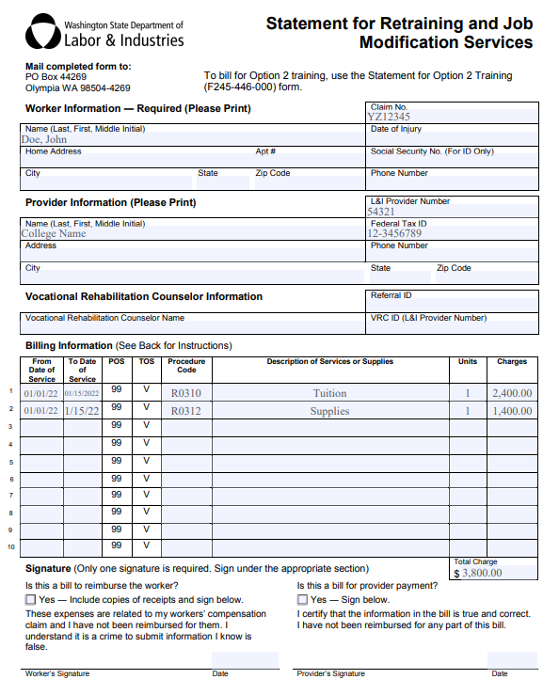

How do I get paid?

Choose direct deposit or mail
- Log in to your ProviderOne account. Update your payment preferences to receive payments electronically through Electronic Funds Transfer (EFT). This is the fastest way to receive payment.
- If direct deposit is not selected, paper checks (called a “warrant”) will be mailed to the provider mailing address.

When do bills process?
Bills process every two weeks on Friday and payments go out the following week. See the calendar at Payment Status.

How do I find out what has been paid?
L&I provides Remittance Advice, also called an Explanation of Benefits (EOB.) This is a statement of what L&I paid, what is pending, and what was denied with the reason for denial.
You can access your Remittance Advice online via your Provider Express Billing (PEB) account or attached to your check (warrant) and Payment Order. These statements are only mailed to the Provider account address and cannot be sent to a third party.
If your original bill is not listed on the Remittance Advice within 60 days, contact PHL@Lni.wa.gov.
To understand your Remittance Advice, refer to the General Billing Guide pages 9 through 16. A list of relevant EOB codes (approval or denial reasons) are listed in the last pages of each Remittance Advice. All EOB codes are available at Explanation of Benefits (EOB) Lookup (wa.gov)

What if I need to re-submit a bill?
If you believe L&I adjusted or denied a bill in error, you can re-submit your bill. Be sure to use the same dates of service as your original bill so L&I can match the bills.
To submit your adjustment via:
- Direct Entry – Follow the instructions in the Adjust, Submit, or Void a Direct Entry Bill (F245-437-000) document. For more information about billing electronically, please visit our Provider Express Billing (PEB) page.
- Paper – Complete a Provider’s Request for Adjustment form (F245-183-000).
- Clearinghouse or your own software - Submit an adjustment transaction through your clearinghouse or software program. If you need additional assistance, please contact your clearinghouse or software vendor.

What if I need to reimburse L&I?
If a school has been paid for a training period but the program ended early, the school may need to reimburse L&I. For calculating refunds, refer to the School Billing Policy. If a refund is needed:
- Complete the form F245-043-000 Refund Notification.
- Mail the completed form with your refund check to L&I at the address on the form.
- Submit your refunds within 30 calendar days of a student’s official withdrawal or termination date.

What if I have billing questions?

VRC
The name and phone number of the assigned VRC is at the end of the Encumbrance form.

L&I websites
- Resources for Training Providers
- School Billing, Cancellation and Refund Policy
- General Billing Guide (F245-432-000) - Includes guide to reading Remittance Advice/EOB
- Submitting Bills and Reports (wa.gov)
- Getting a Payment Adjusted (wa.gov)
- Bill online
  - Provider Express Billing Sign In (wa.gov)
  - Provider Express Billing (wa.gov)

Provider Hotline (PHL)
Email PHL@LNI.wa.gov

School Oversight Program
Email the SchoolOversightProgram@LNI.wa.gov

Glossary
- Authorization Letter – Documents a worker’s Option 2 training benefits including L&I-authorized training sites, dollar limits and date span.
- Billing Code – The terms Billing Code, Procedure Code, Training Code, and Retraining Code are used interchangeably, depending on the on L&I form.
- Encumbrance Form -- Documents a worker’s Option 1 training benefits including L&I authorized training sites, dollar limits and date spans.
- Explanation of Benefits (EOB) – Also known as the Remittance Advice. This is a statement of what L&I paid, what is pending, and what was denied with the reason for denial.
- Labor & Industries (L&I), Washington State - L&I administers worker’s compensation benefits for workers injured on the job in Washington State.
- Option 1 training benefit: The worker chooses to follow the approved L&I retraining plan and continues working with the VRC.
- Option 2 training benefit: The worker chooses their own training path. L&I authorizes limited funds they can use at any L&I approved training provider within five years.
- Option 2 Specialist – An L&I employee specializing in Option 2 training benefits. They create the Authorization Letter and are a resource for workers, schools and other interested parties.
- Procedure Code – The terms Billing Code, Procedure Code, Training Code, and Retraining Code are used interchangeably, depending on the on L&I form.
- Provider Accounts (PAC) – PACMail@lni.wa.gov , L&I’s team of account specialists who review and approve applications and modifications to account information.
- Provider Express Billing (PEB) -- A secure system used to submit bills electronically and receive remittances through a MyL&I account. Providers can submit, adjust, and/or void bills online. Submitting bills electronically is easier, more accurate and you will get paid sooner.
- Provider Hotline (PHL) -- PHL@LNI.wa.gov. This part of L&I Provider Accounts is responsible for answering billing questions.
- ProviderOne – An online account system hosted by HCA. Providers use this online account system to manage their L&I provider account.
- Remittance Advice – Also known as the Explanation of Benefits (EOB). This is a statement of what L&I paid, what is pending, and what was denied with the reason for denial.
- Retraining Code – The terms Billing Code, Procedure Code, Training Code, and Retraining Code are used interchangeably, depending on the on L&I form.
- School Oversight Program – This L&I program seeks to ensure the quality and value of vocational training to improve outcomes for workers. It reviews applications to become an L&I training provider and responds to school-specific questions and concerns.
- Self-Insured (SI) - Employers who provide their own workers’ compensation coverage.
- State Fund (SF) – Workers compensation coverage is administered by L&I.
- Student – Same as Worker.
- Training Code – The terms Billing Code, Procedure Code, Training Code, and Retraining Code are used interchangeably, depending on the on L&I form.
- Vocational Rehabilitation Counselor (VRC): This is a private sector professional who assists an injured worker by assessing the worker’s abilities, developing a plan to return to work and supporting the worker during retraining.
- Vocational Services Specialist (VSS) – An L&I vocational professional who reviews and approves vocational plans from a VRC.
- Warrant – A check L&I issues to a provider.
- Worker – Same as Student.

