Enrolling as an L&I Training Provider

ProviderOne Enrollment Guide
Table of Contents
Getting started 1
What is ProviderOne? 1
Is this the right User Guide for me? 1
How can this Guide help me? 1
What is the process? 2
What information and documents do I need? 2
What if I have questions? 3
Step 1: Basic information 4
Select the enrollment type 4
Basic Information 4
Application ID 6
Business Process Wizard (BPW) 6
Step 2: Add locations 8
Add provider location 8
Add physical location information 8
Add MAILING or pay-to address information 9
EDIT or CORRECT an address 10
L&I specific information 11
Add facility details 11
Delete a location 12
Step 3: Add specializations 13
Adding specializations 13
Deleting specializations 14
Step 4: Add ownership details 15
Individual owner 15
Organization owner 16
Delete ownership information 16
Steps 5-8: SKIP 17
Step 9: Add federal tax details 18
Steps 10-14: SKIP 19
Step 15: Add payment and remittance details 20
Payment details 20
Electronic Remittance Advice 21
Submission information 21
Step 16: Complete enrollment checklist 22
Step 17: Final enrollment instructions 23
Upload information 23
Check the status of your application 28
What’s Next? 28
GLOSSARY 29

Getting started
Thank you for your interest in becoming an L&I training provider!

What is ProviderOne?
ProviderOne is an online portal where you can:
- Apply to become an L&I provider.
- Check the status of your provider application.
- Manage and update your account information.

Is this the right User Guide for me?
Use this Guide if you:
- Are a school or tutoring organization and want to become an L&I training provider.
When you have an L&I provider account, you can bill L&I for tuition, fees, and/or supplies your school provides to a worker who has an L&I approved training plan.
- Have more than one campus or school location. You will need to submit a separate application for each one.
- Need to finish or update your application. Login and select Track Application under the Provider Enrollment tab. You’ll need your Application ID and the Social Security Number (SSN) or Federal Employer Identification Number (FEIN) associated with the application.

Do NOT use this Guide if you:
- Are not a school or tutoring organization. To find the correct User Guide, go to Become a Provider (wa.gov).
- Already have an active L&I Provider Number as a “Training Provider”. To confirm your provider status, go to Vendor Services Lookup (wa.gov) or email the SchoolOversightProgram@LNI.wa.gov
- Want to make changes to your current L&I provider account. Your System Administrator can update an existing account in ProviderOne by logging into http://www.waproviderone.org. Contact SchoolOversightProgram@LNI.wa.gov if you need help setting a System Administrator.
- Have a school based outside of the United States. To become a provider, use the Out of Country Provider Account Application form.

How can this Guide help me?
This Guide will help you skip fields that do not apply to training providers, accurately complete steps that are required, and navigate unfamiliar terms.
Instructions unique to schools are in an orange box.

What is the process?
- Apply online:
https://www.waproviderone.org/ecams/jsp/common/pgNewPrvdrEnrollment.jsp
- Gather the information and documents listed below, complete all required steps, upload documents, and submit the application.
- This process will take approximately 30 minutes if you have the required information available.
- Resume or track your application:
https://www.waproviderone.org/ecams/jsp/common/pgTrackPrvdrApplctn.jsp
  - Enter your Application ID and tax ID.
  - Check for communication. We will contact you if additional information is needed. A Supplemental Application is required if your school is not accredited or licensed.
- Become an L&I training provider.
Once approved, you will receive the following notices:
  - An email from the School Oversight Program with steps to set your System Administrator. This is the person who will manage your online account.
  - A letter from L&I with your L&I account number. This is the number used to bill L&I for authorized training services.
  - A letter from ProviderOne with your ProviderOne ID (domain ID). You need this number to update your account information.
  - A letter from OneHealthPort. If your school does not have a National Provider Identification number (NPI), you can ignore this letter.
- Please note: Applications not submitted within 180 days from the start date will be deleted.

What information and documents do I need?
Information needed
Definitions are in the Glossary.
 | - Business Name | - The legal Business Name as shown on your Business License and IRS documents.  - Your “doing business as” (DBA) name. This may or may not be the same as the legal name
 | - W-9 with your TIN, FEIN, EIN, or SSN | This has your official Taxpayer Identification Number (TIN) from the Internal Revenue Service (IRS). This nine digit number may be a Federal Employer Identification Number (FEIN/EIN) or your Social Security Number (SSN), depending on your business structure.
 | - W-9 Entity Type | Select the type as shown on your Business License: Corporation, Individual/Sole Proprietor, LLC Filing as Corporation, LLC Filing as Partnership, LLC Filing as Sole Proprietor, Partnership, Other.
 | - UBI | A Unified Business Identifier (UBI) is the nine-digit number assigned to a business when you register with the Washington Department of Revenue, Department of Employment Security, or the Secretary of State.
 | - Address(es) | Street, city and ZIP code of your primary business or administrative location, physical location, mailing address, and pay-to address.
 | - Contact | Contact information for the person who will:  - Receive email notifications about this application.  - Act as a contact for the school regarding billing, account information, or student enrollment.  Required: Name, address, phone, and email.  Optional: Fax and website.
 | - Owners | If applicable to your organization, identify the owners, and/or managers with controlling interest. For each, you will need:  - Legal names  - Percentage of controlling interest  - Tax identification number  - Birthdate and disclosure date (the date of first ownership)
 | - License or Accreditation | If your school is licensed and/or accredited, upload documentation containing the:  - Licensing or Accreditation number and the licensing or accreditation body.  - Effective date, end or expiration date, and the State in which the school is licensed or accredited.  If the school is unlicensed or not accredited, complete the Supplemental Application (available in Step 17.)
 | - Payment | - Decide if your organization wants to receive paper checks or Electronic Funds Transfer (EFT), also known as Direct Deposit.  - If EFT, include the Financial Institution Routing Number.  - If email communication is selected, identify a valid email address and authorized contact person.

What if I have questions?
Email SchoolOversightProgram@LNI.wa.gov for questions about completing your application, checking account status, or for technical support and accessibility assistance.
Visit our website at Schools and Training Programs (wa.gov) for more resources.

Step 1: Basic information
Notes:
- The terms “Training Provider” and “School” are used interchangeably in this Guide.
- Required fields have an asterisk (*).
- The application will save information after each step is completed.
- You can return to your application using the Track Application link: https://www.waproviderone.org/ecams/jsp/common/pgTrackPrvdrApplctn.jsp

Select the enrollment type
Select either:
- Fac/Agncy/Orgn/Inst (Facility, Agency, Organization or Institution).
- Individual if you are an individual training provider, such as a tutor.
- Click Submit to open the Basic Information popup window.

Basic Information
Training Providers should ignore the message that says,
“If you don’t have NPI or you are an Atypical provider, please contact DSHS to enroll.”

- Under Available Agencies, select L&I.
- Click the right arrows >> to move your selection to the box on the right.
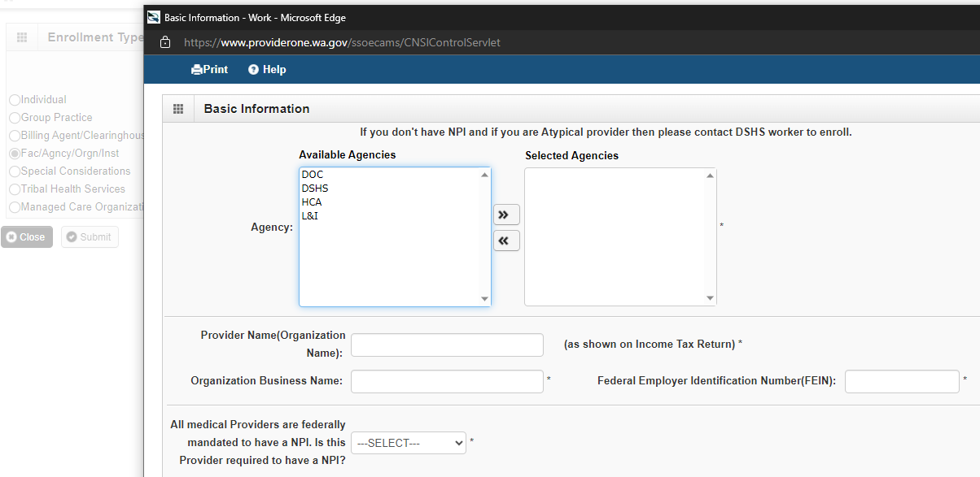
- Provider Name (Organization Name): Enter the legal name as listed on line 1 of the W-9.
- Organization Business Name: Enter your “doing business as” (DBA) name as listed on line 2 of your W-9 (this may or may not be the same as your legal name.) This name will be used in L&I’s system.
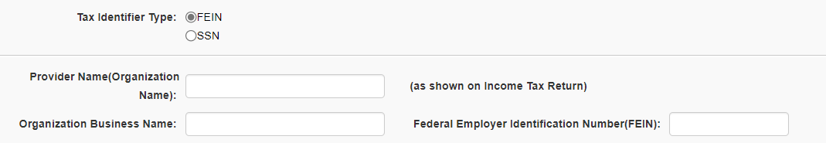
- Federal Employer Identification Number (FEIN): This is your Tax ID. Enter your FEIN. If you are an Individual or do not have an FEIN, enter your SSN.

For the remaining fields:
- “Is this provider required to have an NPI?”: Select No. Most Training Providers do not have an NPI. The system will auto-generate a unique number for this field.
- UBI: Enter the Unified Business Identifier (UBI) number from your Business License.
- W-9 Entity Type: Select the entity type listed on your Business License or IRS documentation, such as Partnership, LLC, or Corporation.
- Public schools should select “Other”. Then enter a description of your school type in the enabled field W-9 Entity Type (If Other).
- Other Organizational Information: Use the drop down arrow and select the nature of your organization. (For definitions, look for “W-9” in the Glossary.)
  - Private schools should select their business structure (For Profit, Nonprofit).
  - Public schools should select “Government”.
- Email Address: Your Application ID number will be sent to this email address and any questions about your application or provider account.
- Enrollment Effective Date: Do not enter an enrollment effective date.
- Click Next to generate your Application ID.

Application ID
Your Application ID displays at the top of each step in the application process. Keep your Application ID available, you’ll need it to:
- Save and return to an incomplete application.
- Track your application status once submitted.
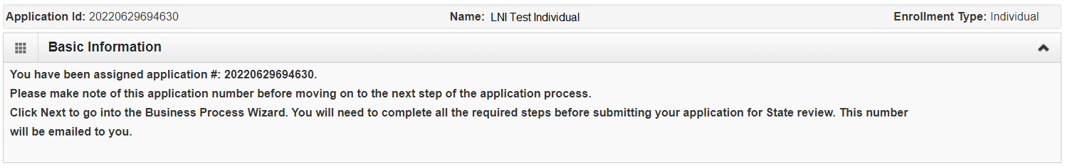
- Update or add information, if requested.
Please make note of this application number before moving to the next step…

ProviderOne will also email your Application ID to the email address provided.

This email also includes a link to the Nondiscrimination statement | Washington State Health Care Authority. All L&I providers are expected to adhere to this policy.

Business Process Wizard (BPW)
The Business Process Wizard (BPW) lists the required steps to finish the application.
All required steps must be completed in order. A step shows as incomplete until all requirements within the step are met. To proceed to the next Step, click on the Step name in the first column.
To return to the Business Process Wizard at any time, click Close or Cancel at the bottom of a window or click “Enrollment” at the top of any step.
To delete the application and start over from scratch, click “Purge.” A message will say, “Are you sure?” If you select yes, all data will be eliminated.

Step 2: Add locations

Add provider location
Click Add to designate your “NPI Base Location”. This is your primary business/ administrative location. The Base Location requires three addresses:
- Location: The physical address of the primary location.
- Mailing: The place where you receive mail.
- Pay-To: The place where payment, tax forms, and pay statements (remittance advice) are sent.
For schools with multiple campuses, submit a separate application for each location. Each location will receive its own L&I provider number for billing and will appear in L&I’s Vendor Services Lookup (wa.gov) .

Add physical location information
- Location Type: Use NPI Base Location, the default value. This is the location where training will occur. Do not select Social Services Location.
- Business Name at this Location: Enter the name of the business at this location. (This may or may not be the same as your Provider name or DBA.)
- End Date: Leave this blank. Do NOT enter an end date.
- Contact First Name and Last Name: Enter the name of the person to be contacted at this location for administrative or billing questions.
- Click Add Address and enter the address where the training will occur. This must be a physical address, do not use a PO Box. Even if training is offered online, a physical address is required.

- If the address is valid, you will see the following message:
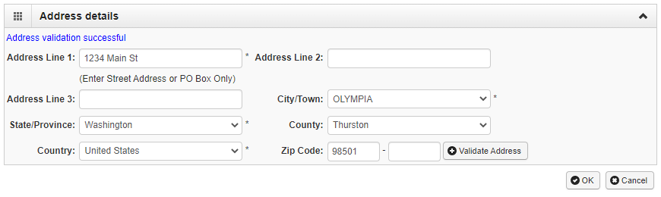
- If the address is not found, you will see:
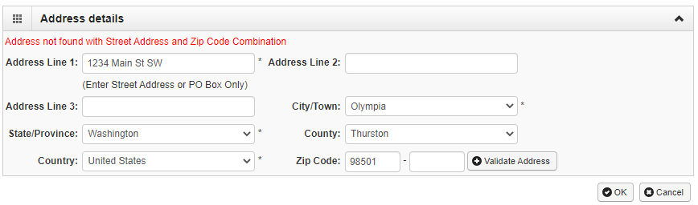
- Click Cancel to correct the address.
- Click OK to continue with the address as-is. A pop up window will appear. Click OK to save and continue.
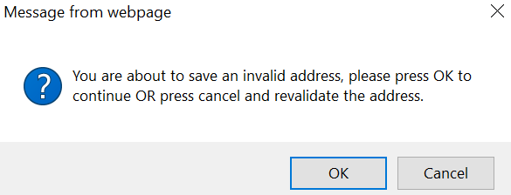

Add MAILING or pay-to address information
If the Mailing and Pay-to address are the same as the NPI Base Location, select Same as Location address to autofill the information.
The Pay-to address must match the address on your W-9. If the address is invalid, payment and correspondence, including tax documents and billing statements, may be delayed.
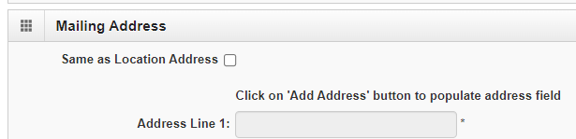

If this address is different, click Add Address, enter and validate the address information.

Enter the remaining contact information for this location.
- Phone Number (Required)
- Fax and Cell Phone Number (optional)
- Email Address
- Communication Preference: This is how L&I will contact you. If you choose to receive payment via Electronic Funds Transfer (EFT or Direct Deposit), you must select Email and provide an email address.
- WA Tax Revenue Code: Leave this blank.
- Web Page

EDIT or CORRECT an address
To correct or change an address, click on the address type and Add Address to make changes.
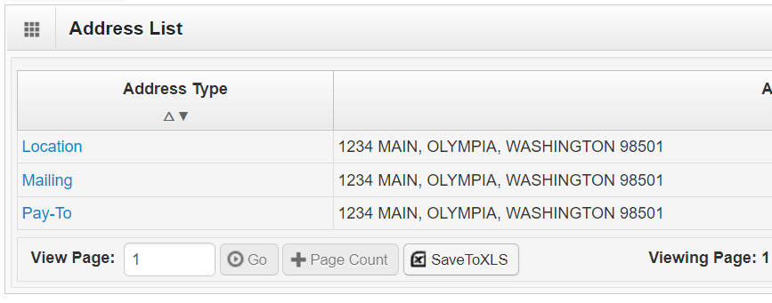

L&I specific information
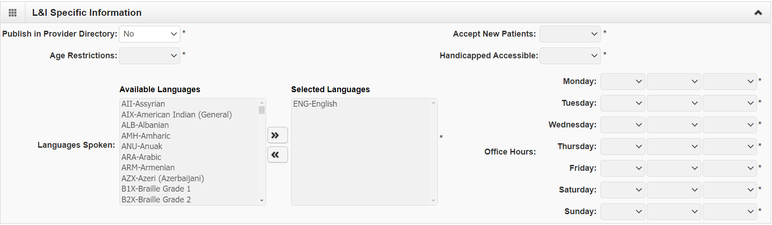
Publish in Provider Directory: Select No. This Provider Directory is for medical providers. Training Providers are on a separate list on the Vendor Services Lookup (wa.gov) page.

Add facility details
- State Facility ID – Leave this blank. This is not applicable to Training Providers.
- Accreditation - Select the default “No”, even if your school is accredited.
- Distinct Part Unit - Leave this blank or select the default “None”.
- No. of Licensed Beds - Enter “0”.
- Fiscal Year End Date - Enter 12/31/2999 to satisfy the required field.
- Pharmacy Details – Skip this section.
- Regional Suport Network Details – Skip this section.
- Scroll to the bottom of the page and click OK. 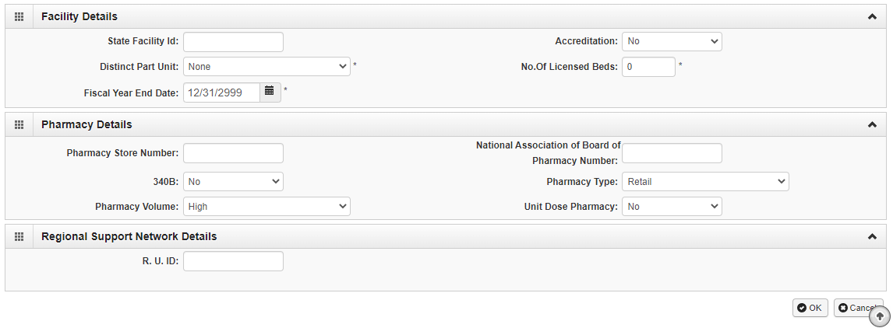
Verify the NPI Base Location was successfully added in the Locations list on the next page.
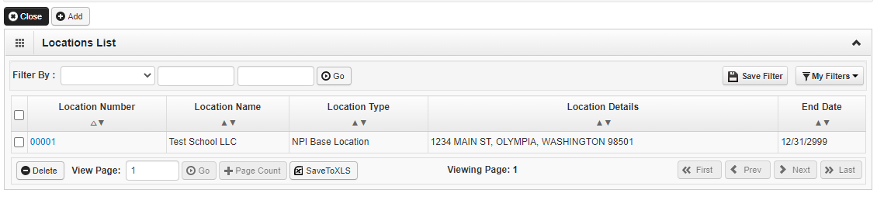
- Click Close at the top of this page to return to the Business Process Wizard (BPW).
Note: If your school provides services at more than one location or campuses, add additional locations on this page. Each location will receive its own L&I provider account number.

Delete a location
You can only delete a location during enrollment. When a location is deleted, all step details associated with that location, including Specialties, and Licenses/Certifications will be deleted.

To delete a location, check the box next to the location number and click Delete.
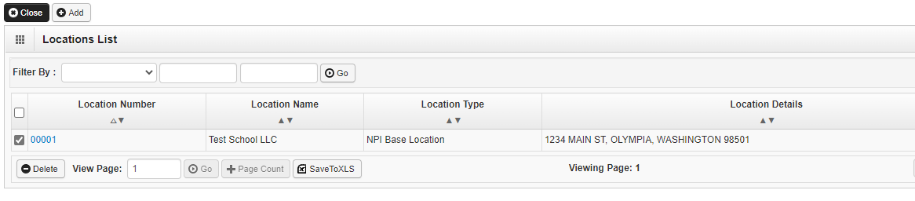

Step 3: Add specializations
L&I uses specialization codes to distinguish provider types such as schools, medical, etc.

Adding specializations
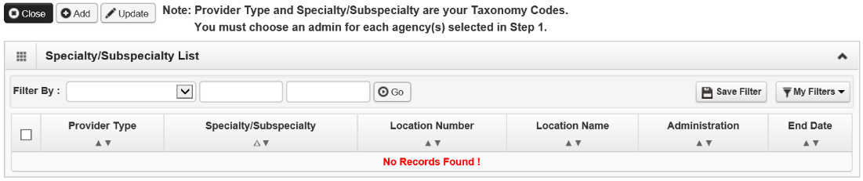
Click Add.

- Select a specific location or All from the drop-down menu.
- Choose L&I from the Administration drop-down menu.
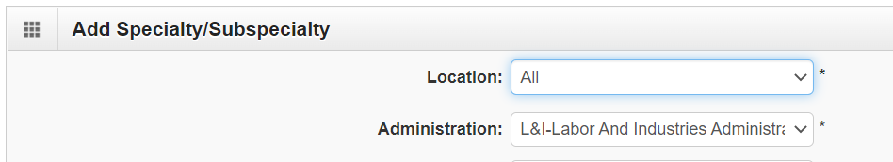

- Provider Type: Select 17-Other Service Providers.
- Specialty: Select TS-Transition Services.
- End Date: Leave this blank. ProviderOne will auto-populate to 12/31/2999.
..
Add Taxonomy Code
- Click the right arrows >> to move your selection to the box on the right.
- Select Accredited/Licensed Training Provider if your school is accredited or licensed, select.
- Select Non-Accredited/Unlicensed Training Facility if your school is NOT accredited or licensed. You must complete a Supplemental Application in Step 17: Final Enrollment Instructions.
- Do not select Day Care, Rehab Training Facility, or Vocational Testing.
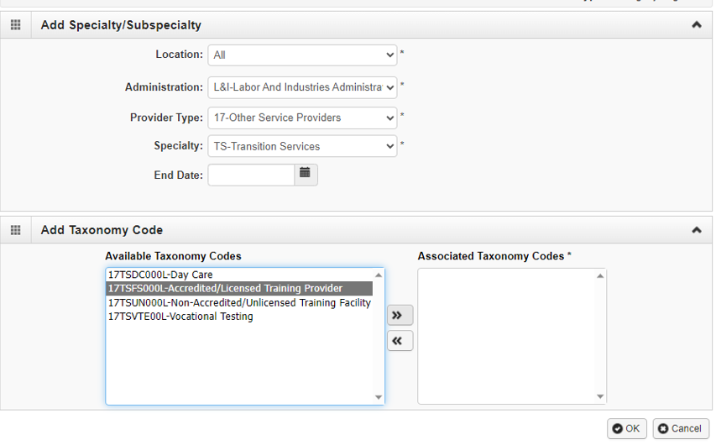
- Click OK to save or Cancel to close without saving. Click Close to return to the Business Process Wizard (BPW).

Deleting specializations
Specializations can only be deleted during the enrollment process.Check the box next to the record you want to delete and click Delete.
Click Close and go to the next step.

Step 4: Add ownership details
Select Individual if an individual owns all or part of this school.

Select Organizational if another entity owns or holds controlling interest in the school.
Public schools and government entities that are exempt from ownership disclosure, can use Organizational Owner. Individual managing employees and/or a Board of Directors must be disclosed.

Both Individual or Organizational types require at least one owner to complete this step.

Providers are required to disclose all Owners, Managing Employees, and Board of Directors (per CFR 455.104 and CFR 455.101 (Definitions for Disclosures).

Click Add to select the ownership type that best fits your organization.

Individual owner
Select this option if an individual owns all or part of this school.
Repeat these steps as needed for additional owners or other individuals, such as a board of directors or managing employees.
- Disclosure Category: Select Owner.
- Disclosure Type: Select Individual.
- SSN/FEIN: Click Copy name and Tax button or enter the relevant tax ID.
- Doing Business As: (optional)
- Minority/Women Owned Business Enterprise (MWOBE): (optional) For more information, go to Certification | MWOBE (WA State).
- Name and Date of Birth (required): Enter the owner/manager’s name and date of birth.
- Disclosure Start Date (required): Enter the date each individual gained ownership.
- Disclosure End Date: Leave this blank.
- Add Address: This may be the same as the location address.
- Ownership Percentage (required): For multiple owners, the total percentage must equal 100. Do not include the “%” symbol.
- Owner Association: Disclose any controlling interests, managing employees or members of a board of directors that are related to the owner(s). This includes children, parents, siblings, or spouses.
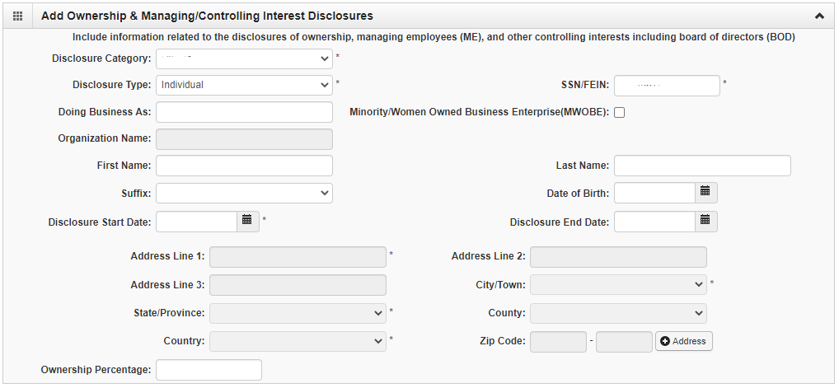
Click OK to save or Cancel to close without saving.

Organization owner
Select this option if another entity owns or holds controlling interest in the school.
Public schools and government entities should use this disclosure type.
- Disclosure Category: Choose Owner
- Disclosure Type: Choose Organization
- Click Copy name and Tax button to use the business name and tax ID.
- Disclosure start date: Enter a relevant date such as the date the school was founded, joined its college district, etc.
- Click Add Address and complete the steps.
- Ownership Percentage: Enter 100
Note: If Organization Owner is selected, an individual Managing Employee must be disclosed. Follow the steps above to enter Managing Employee’s information.

Click OK to save or Cancel to close without saving.

Delete ownership information
Ownership information can only be deleted during the enrollment process.
Check the box next to the record you want to delete and click Delete, then close.
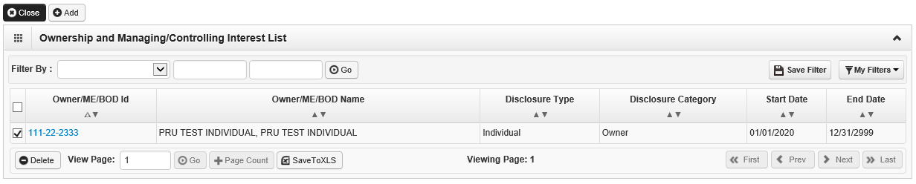

Steps 5-8: SKIP
These steps are not required for L&I training providers.

Step 9: Add federal tax details
The information on this screen must match the W-9 form you’ll upload in the last step of the BPW. Click the W-9 link to modify the information in this step. Click W-9 Form to view the Form W-9 and Address.

Form W-9:
- Legal Name: This autopopulates from the Provider Name (Organization Name) in Step 1: Provider Basic Information and must match line 1 on the W-9. To change or correct information in these fields, Close and return to Step 1.
- Business Name: This is line 2 on your W-9. Enter the organizational business name (or DBA) provided in the basic information section of the application.
- Exempt from Backup Withholding: This is a field on your W-9.
Address:
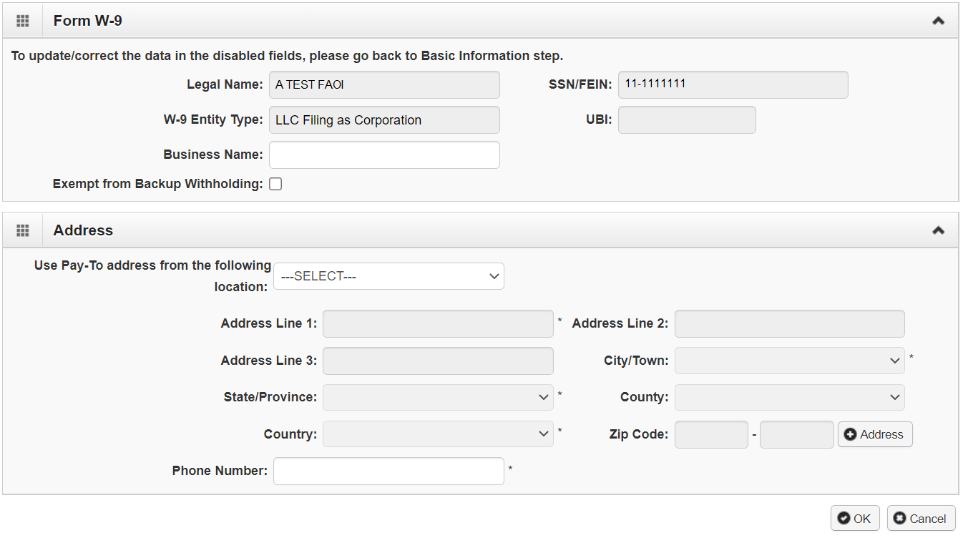
- Use the drop-down menu to select the base location. The Pay-To address will auto-populate the address fields. The Pay-To address should match your Federal Tax data.
Click OK to save or Cancel to close without saving.

Steps 10-14: SKIP
These steps are not required for L&I training providers.

Step 15: Add payment and remittance details
Payment for tuition or training services is available by paper check (“warrant”) or Electronic Funds Transfer (EFT/Direct Deposit). Payment information applies to all locations.
Click Add.
Provider Information will autofill and cannot be changed in this step.

Payment details
Choose Electronic Funds Transfer (Direct Deposit) or Paper Check.
EFT/Direct Deposit is the fastest way to receive payment, once your financial institution verifies the data entered (approximately 7-10 days.) If not verified, you will receive a failure notice and payment will default to paper check.
- Financial Institution Name: Enter the name of your banking institution.
- Financial Institution Routing Number: Enter the 9-digit routing number
- Providers Account Number with Financial Institution: Enter your account number (usually 10-12 digits).
- Type of Account: Select Checking or Savings
- EFT Account Type: Select Corporate or Personal.
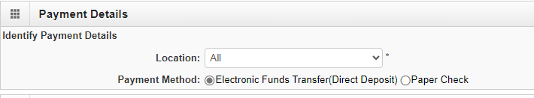
- Payment Notification Preference: Use the dropdown arrow and select Email or Letter. You must designate an email in Step 2 to receive email payment notification.

Paper Check. The check (warrant) will be mailed to the Pay-To address.

Electronic Remittance Advice
This step is not required for L&I training providers.

Submission information
Reason for Submission: Use the drop-down menu and select New Enrollment.
Authorized Signature: Enter the name of the person authorizing this payment information and click OK.

The following message will appear if EFT/Direct deposit is selected.
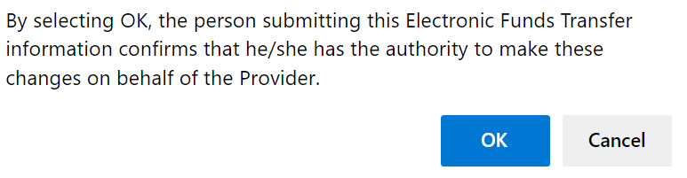

Click Close to return to the BWP list.

Step 16: Complete enrollment checklist
Training providers can select No for medical provider-related questions.

Answers are required for each questions on this checklist.

The fourth question applies to both schools and their instructors, “Had a restriction or sanction taken against their professional license or certification?”

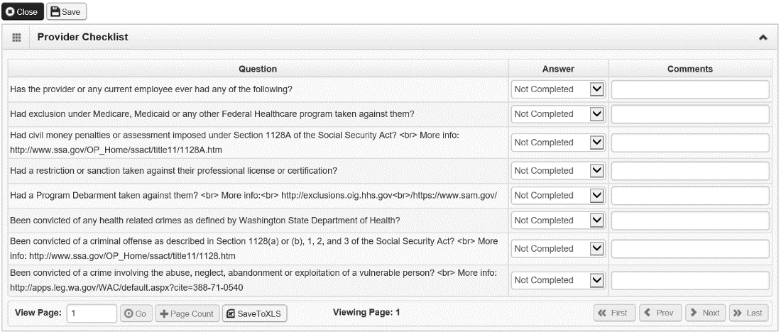

Click Save and Close to return to the Business Process Wizard.

Step 17: Final enrollment instructions
All required documentation must be uploaded before submitting the application. Incomplete submissions will delay the approval process and your ability to bill L&I.
Required documents include:
- Provider Agreement: This document was originally designed for medical providers and some statements do not apply to training providers.
- W-9: Signed and dated. Electronic signatures are not accepted. Information provided in the application must match this form.
- Proof of Accreditation or Licensing: including the provider name, the name of the accrediting/licensing body, the effective date, and expiration date.
- If not Accredited or Licensed, upload a completed Supplemental Application.
Links to required forms are available in the Application Document Checklist.
If you have questions about these forms, email the SchoolOversightProgram@LNI.wa.gov
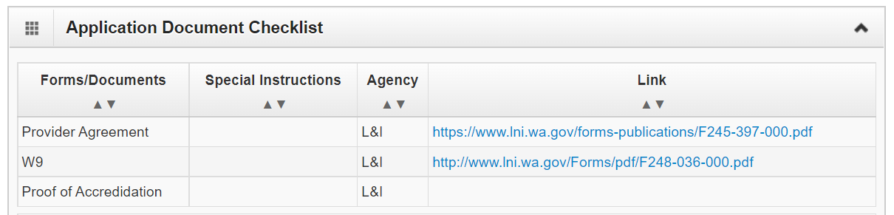

Upload information
Click Upload Attachments.
Click Add Attachments.

Identify the document you want to upload.
- Attachment Type: Use the drop-down menu to select the appropriate type.
- Request Type: Use the drop-down menu to select:
  - Enrollment Appliction if you are submitting a new application or
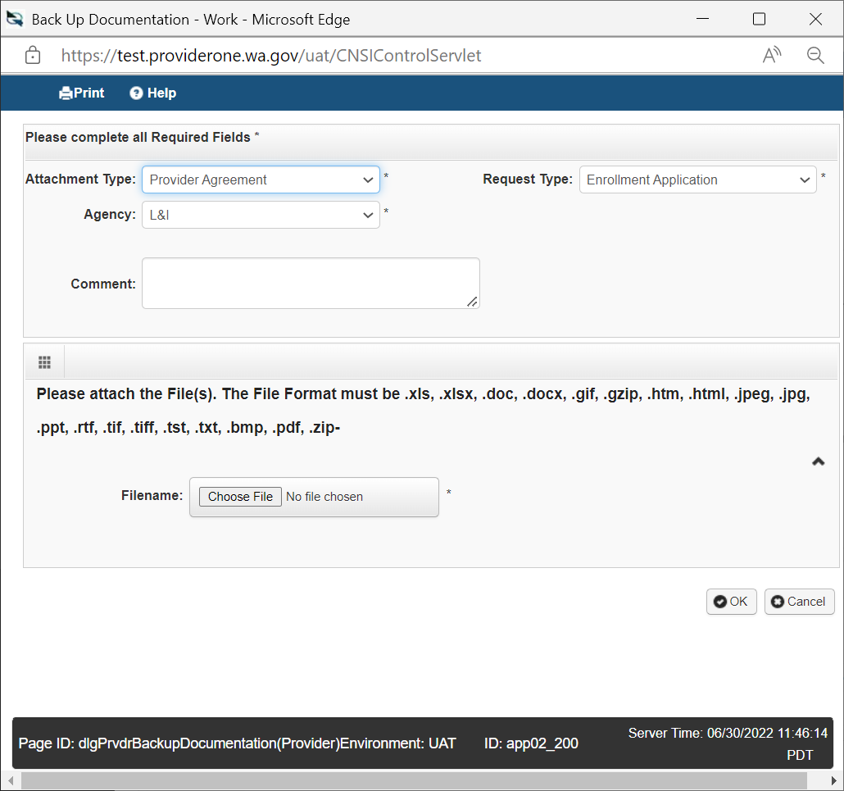
- Comments: Type in comments, if applicable.
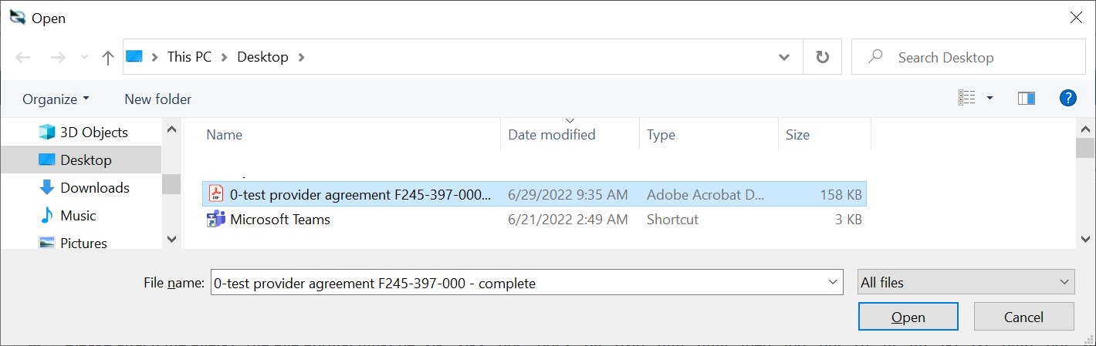
Click Choose File , select document and click Open. Once your file has uploaded, click OK
Once all required documents have been uploaded, click Cancel.
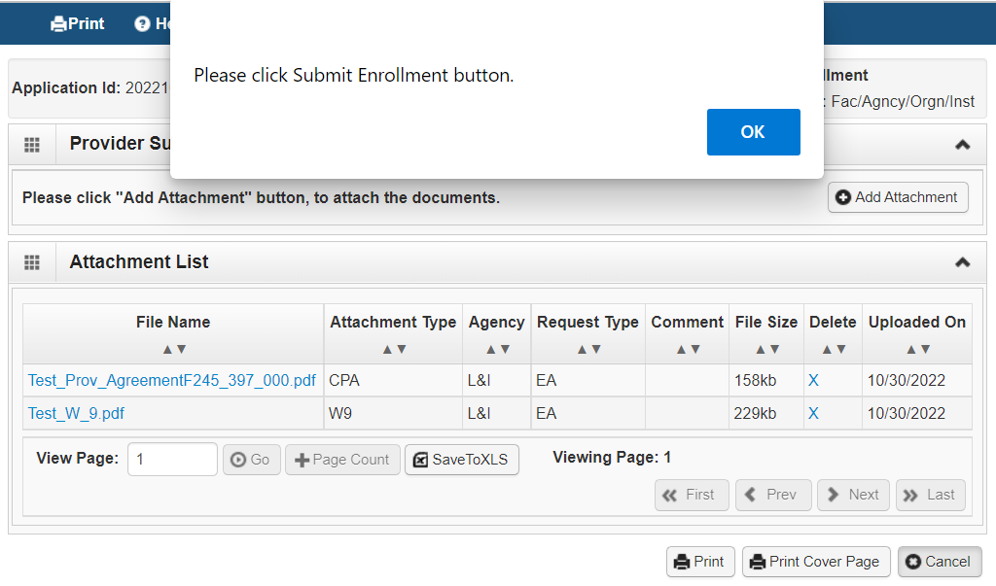
A popup window will display “Please click Submit Enrollment button.”. This is just a reminder and will NOT submit the application. Click OK.
Repeat the steps above to upload additional attachments.

Delete a document
If you upload an incorrect document, you can delete it. Any incorrect documents must be deleted before you submit your Application.
- Go to the page Provider Supporting Documents.
- Click on the ‘X’ under the Delete column next to the file you would like to delete.
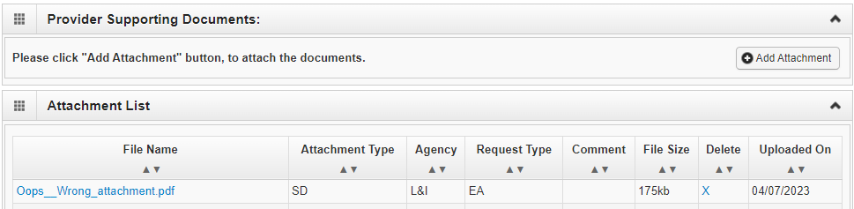
- The following pop-up will appear. Click OK to return to the attachment list.
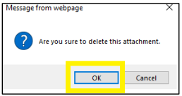
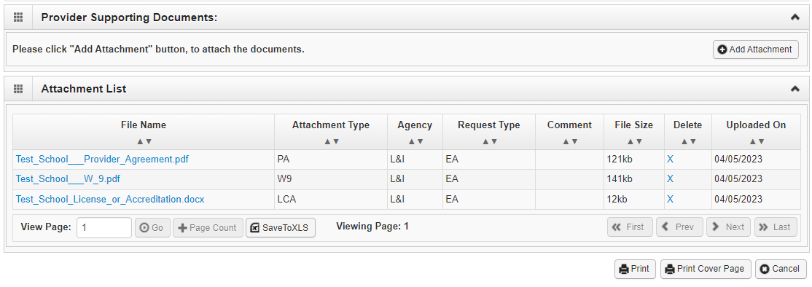
Additional documents
If you have additional documents to upload, you may click the Add Attachment button and repeat instructions above.
Verify all required documents have been uploaded.
You MUST upload required documentation before you submit your enrollment application. An application with incomplete documentation will delay the approval process and your ability to bill L&I. Required documents for schools include:
- Provider Agreement
- W-9
- A brief description of the nature of the training services you provide such as tutoring, driving school, etc.
- Proof of Accreditation or Licensing
- If your school is Accredited or Licensed:
Upload documentation with the name of your training organization, the name of the Accrediting and/or Licensing body, and the effective date and expiration date.
- If your school is not Accredited or Licensed:
Complete the Supplemental Application and upload it. If you have questions about this form please email us at SchoolOversightProgram@LNI.wa.gov.

Once you have uploaded all documents, click Cancel to return to the previous screen.
A popup window will say “Please click Submit Enrollment button.” This button does NOT submit the application. Click OK to go to the final submission step.

Click Submit Enrollment
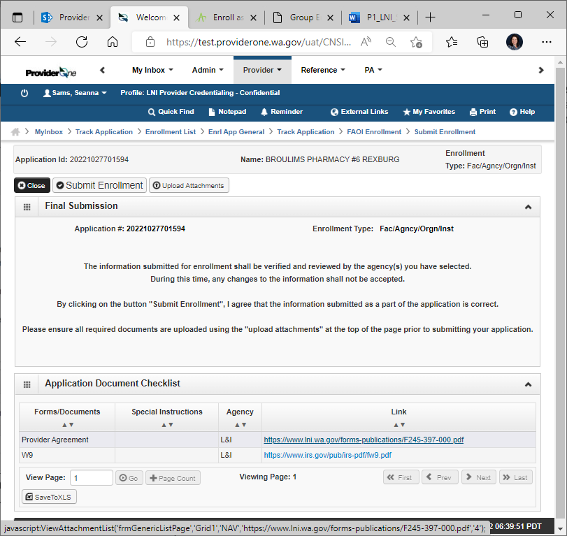
If the application is successfully submitted, you’ll receive a pop up message. Click OK to close.

Click Close on the Final Submission page.
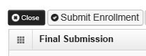
The Business Process Wizard (BPW) will show all required steps as complete.
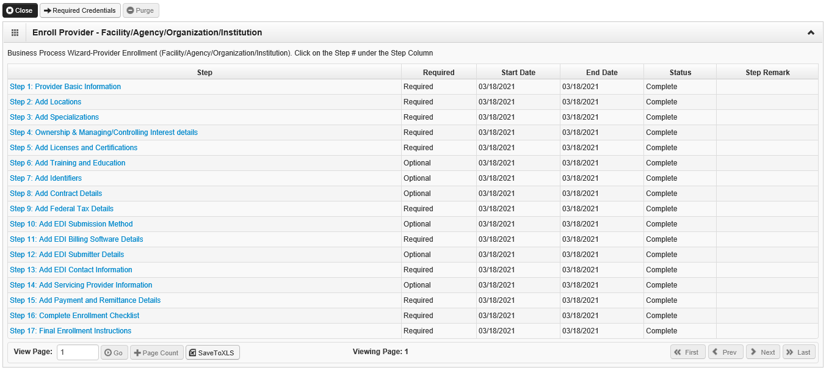

Congratulations! You have submitted your application!

Check the status of your application
- Enter your Application ID and and either your Social Security Number (SSN) or Federal Employer Identification Number (FEIN).
- A pop-up message will display the status.
- Questions? Email us at SchoolOversightProgram@LNI.wa.gov.

What’s Next?
We will review your application and contact you if we have questions.
See “The process” section at the beginning of this Guide.
For more information
- Visit the Schools and Training Programs (wa.gov) website.
- Email the SchoolOversightProgram@LNI.wa.gov
- Visit the Become a Provider website.
NOTE: Applications are deleted if not submitted within 180 days.

GLOSSARY
Verify as needed with L&I Acronym Glossary - Inside L&I (wa.gov)
Term | Explanation
Accredited | For training providers: The US Department of Education evaluates accreditation organizations and publishes a list of recognized organizations on their website that meet their quality criteria.  For Washington State, the Regional accrediting body is the Northwest Commission on Colleges and Universities (NWCCU). It focuses on degree-granting, post-secondary schools.
Account Number | Providers Account Number with Financial Institution: Your account number (usually 10-12 digits) is specific to your personal account. It’s the second set of numbers printed on the bottom of your checks, just to the right of the bank routing number.
Application ID | After you complete the Basic Information Step 1, the system generates a unique Application ID for you.  SAVE this application ID! You will need this number if you exit the enrollment process prior to completion. You will need it to return to your application, make changes, and track your application status.  It is displayed at the top of each step in the application process.
Business Process Wizard (BPW) | BPW helps you navigate the sections in your application. It lists the Steps needed to submit your application, displays which steps are Required or Optional, and the Status (Complete or Incomplete) of each Step.
Electronic Funds Transfer (EFT) | Direct Deposit. This is usually the fastest and easiest method of receiving payments from L&I, or making adjustments to bills.
Explanation of Benefits (EOB) | A statement L&I sends to providers regarding billing and payments. It is also known as Remittance Advice (RA). It identifies monies received, paid, denied, or pending, with required explanations. It can be either paper or electronic.
Fac/Agncy/Orgn/Inst (FAOI) | FAOI stands for Facility, Agency, Organization, Institution and is one of seven Enrollment Types in ProviderOne.
Federal Employer Identification (FEIN) | This has your official nine-digit Taxpayer Identification Number (TIN) from the Internal Revenue Service (IRS).
Financial Institution Routing Number | The routing number is a 9-digit number that identifies the specific financial institution responsible for the payment of a negotiable instrument.
L&I | Washington State Department of Labor and Industries. See web pages at Labor & Industries (L&I), Washington State
L&I Provider Accounts (PAC) | Provider Accounts & Credentialing (PAC) is a program at L&I that processes provider applications and ensures providers receive proper reimbursement for their services.  They will review basic information from your ProviderOne application and then forward the application to the L&I School Oversight Program for a final decision.
L&I School Oversight Program | A program at L&I that monitors vocational training programs for injured workers.  This program will review your application and approve or deny your application. Questions can be addressed to SchoolOversightProgram.LNI.wa.gov
Letter of exemption | L&I requires this form for all schools that are not licensed or accredited. It is a statement verifying your organization is exempt from licensing/accreditation requirements.  In Washington State, this can be obtained from the relevant licensing or accreditation body, such as the Department of Licensing, or the Eligible Training Provider (ETP) list maintained by the Workforce Education and Training Coordinating Board (WTB).  If you are located outside Washington State, contact the relevant, similar agency or licensing body in your state.
Licensed | For training providers, this is an official designation from a relevant licensing body, such as the Department of Licensing.
Minority/Women Owned Businss Enterprise (MWOBE) | The Office of Minority and Women’s Business Enterprises (OMWBE) certifies small businesses owned and controlled by minority, women, and socially and economically disadvantaged persons.  For businesses located in Washington State, you can find information at Certification | Office of Minority and Women's Business Enterprises (wa.gov) .
Organization Name | The legal name as registered with the Internal Revenue Service (IRS) and is on your Tax ID document.  Your Doing Business As” (DBA) name may or may not be the same as your legal name.
National Provider Identification number (NPI) | This number is required for all medical organizations.  Training Providers are NOT required to have an NPI. ProviderOne auto-generates a generic number (not an official NPI number) that L&I can use for the required field in your application.
NPI Base Location | This is your primary business/administrative location. You can ignore the “NPI” portion of this label since training providers do not have NPI numbers.
ProviderOne | An online provider account system.
Remittance Advice (RA) | A statement L&I sends to providers regarding billing and payments. It is also known as the Explanation of Benefits (EOB). It identifies monies received, paid, denied, or pending, with required explanations. It can be either paper or electronic.
Routing Number | A bank routing number is a 9-digit code used to identify a financial institution in a transaction.
Social Security Number (SSN) | This nine digit number is generated by the U.S. Federal government. It is used to uniquely identify earning records for individuals and is used for tax purposes and to determine Social Security benefits.
Supplemental Application | All training providers who are not licensed or accredited are required to submit this form.  - It is available at https://lni.wa.gov/forms-publications/F280-045-000.pdf  - And/or contact the SchoolOversightProgram@LNI.wa.gov for more information.
Unified Business Identifier (UBI) | This nine-digit number is assigned to a business when they register with the Department of Revenue, Department of Employment Security, or the Secretary of State.
W-9 Entity Type  (if Other) | - For Profit: A business or entity created for profit under and governed by 23B RCW. A corporation issues stocks or shares and distributes profits to shareholders*.  - Government: A local, state, or federal agency or governing body .  - Nonprofit: A business or entity structured formed to benefit the public good.Formed to benefit the public good and structured under under chapter 24.03A or 24.06 RCW.  - Not for profit: “Recreational” organizations that do not operate with a business goal of earning revenue. This entity type may form as a for-profit structure, but does not operate for profit.  - Retail: A person or entity, including the state and its departments and institutions, making sales at retail or retail sales to a buyer, purchaser, or consumer per 82 RCW.  - Tribal: a sovereign tribal nation with a formal nation-to-nation relationship with the US government.

