Completing the Physical Medicine Progress Report F245-453-000 (PMPR)

- Use this form to communicate your patient’s progress with the attending provider (AP), Labor and Industries, and others as appropriate. When signed by the attending/referring provider, it lets everyone know they are aware of the individual’s progress.
- Physical therapists (PT) and occupational therapists (OT) who provide standard outpatient therapy based on WAC 296-23-220 and WAC 296-23-230 must use this form for workers covered under the state fund. This also includes work conditioning programs unless your work conditioning progress report meets work hardening program requirements with a comprehensive summary of the individual's capacity level.

- The PMPR is not required for home health, inpatient rehabilitation, out-of-state providers, consulting therapists, or work hardening programs. In addition, the form is not required for a standard outpatient therapy initial evaluation or discharge summary.

- The treating PT or OT completes this form and sends prior to the patient’s AP visit. At a minimum, progress reports must be monthly or every 12th visit with the patient. Submit this form with your request for additional authorization if not already sent to L&I.

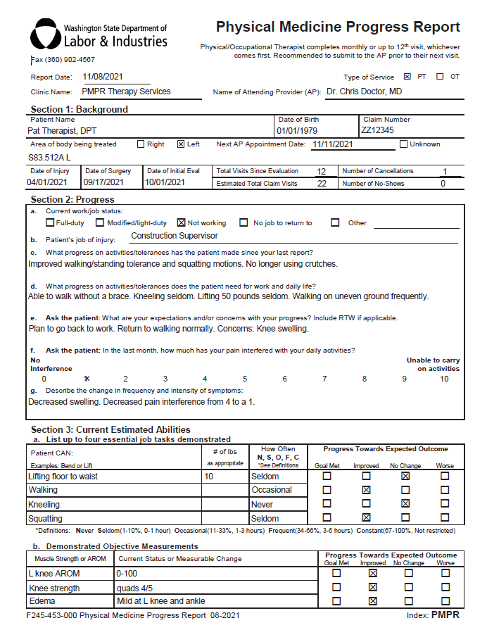
Section 2:
We encourage you to ask your patient to answer the questions e. and f. during their session.
- a – May make multiple selections.
- c, d, g – Therapist’s impression of progress and needs.
- e, f – Patient response.
1
Select either OT or PT.

Use the date format MM/DD/YYYY or the calendar drop down.

Area of body being treated: You may choose to enter a diagnosis/ICD 10 code

If no surgery, leave blank.

If no missed visits, enter zero (0).

3
2
Your treatment goals are reflected in Section 3.

At least one entry is required in 3, a. If functional tasks are medically prohibited, indicate why.

How often is an estimate based on your clinical judgement. Enter the full text for each choice.

Never | Unable to perform
Seldom | 1-10%, 0-1 hour
Occasional | 11-33%, 1-3 hours
Frequent | 34% - 66%, 3-6 hours
Constant | 67-100%, Not Restricted
Time is based on full time 8-hour day.
4

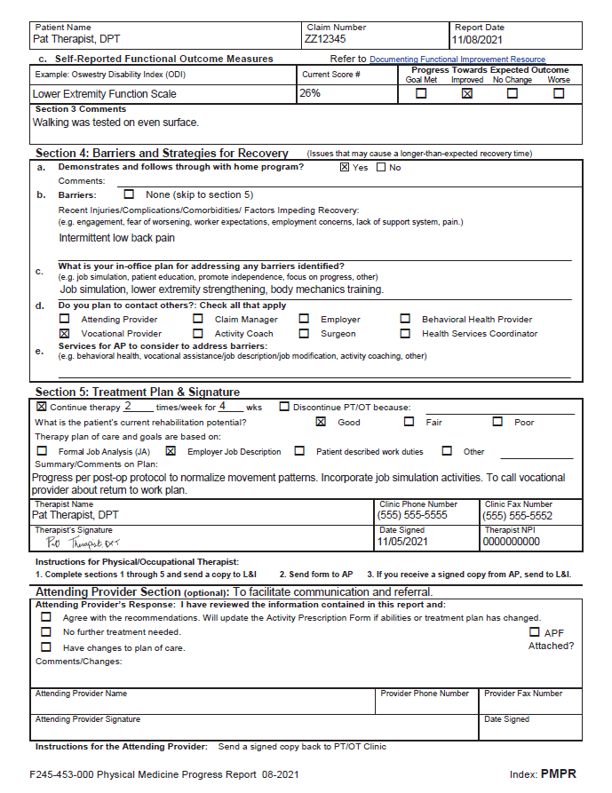
L&I fax: 360-902-4567

6

If no barriers are identified, check None and skip to Section 5.

If barriers are identified, list them in Section 4b.
- Enter your plan for addressing these barriers by listing methods in Section b, c, and d.
For any comments on Section 3 a, b and c, use the Section 3 comments field.

For a list of possible functional outcome measures, see L&I’s Options for Documenting Functional Improvement Resource.

5

7
5

What to do if there is a break in care?
If your patient is on hold and has not been seen since your last progress report, another report is not required when on hold.

