Industrial Insurance Medical Advisory Committee Meeting
Meeting Minutes

April 22, 2021
Preparation: Suzyn Daniel
Attendance Record: Kelly M Miller
Committee Members:
- Andrew Friedman, MD (Chair)
- Kirk Harmon, MD (Chair)
- Jiho Bryson
- Laurie Gwerder
- Linda Seaman
- Louis Lim
- Mike Codsi
- Monica Haines
- Robert Lang
- Stephen Thielke
- Chris Howe
L&I:
- Cheri Ward – L&I
- Gary Franklin – L&I
- Jason Fodeman – L&I
- Jason McGrew – L&I
- Jennifer Jonely
- Jennine Griffo – L&I
- Joel McCullough – L&I
- Karen Jost – L&I
- Kelly Miller – L&I
- Lee Glass – L&I
- Lyn McClendon
- Megan Lemon
- Morgan Young – L&I
- Nikki D’Urso – L&I
- Suzyn Daniel – L&I
- Zach Gray – L&I

Draft Minutes

April 22, 2021

Meeting called to order - Chair, Dr. Andrew Friedman w/quorum present @ 1:05 pm.

Welcome
- Safety Tip: Bicycle Safety - Andrew Friedman
- Minutes from April Meeting
*Actions taken or requested: 01-28-2020 meeting minutes approved
^^Decision made: All approved

Lumbar Spine Guideline Draft*– Chris Howe, Zach Gray
The final draft of the Lumbar Spine Guideline was presented. Written public comment period will be May-June 2021. Public comment (virtual) and full committee vote will happen in July.
*Actions taken or requested: Call for written Public Comments
^^Decisions made: Public comment discussion and vote will commence at July meeting
Evaluation and Management Policy Updates, MARFS 2021 – Megan Lemon
Presentation included background information pertaining to upcoming fee schedule changes that will be available for viewing 6/1/2021 and effective 7/1/2021.
Resources and links provided:
- HPPM@lni.wa.gov
- Medical Aid Rules and Fee Schedules
- https://lni.wa.gov/patient-care/billing-payments/fee-schedules-and-payment-policies/policy-2021
- AMA MDM grid https://www.ama-assn.org/system/files/2019-06/cpt-revised-mdm-grid.pdf
- Documentation education resource https://lni.wa.gov/patient-care/advisory-committees/_docs/2016OccupationalHealthDocumentationResourceWeb.pdf
*Actions taken or requested - None
^^Decisions made – None

World Health Organization Disability Assessment Schedule (WHODAS) Usage* – Morgan Young
Pertaining to WHODAS usage, two different drafts were presented with articulating problem statements, background, recommendations for change, and associated rationale.
- Allow alternatives to WHODAS 2.0 that are substantially equivalent, validated instruments and list them in the “Authorization and Reporting Requirements for Mental Health Specialists” document and relevant IME policies. This will not remove WHODAS 2.0 as a valid option.
- Change the use of WHODAS or other validated instruments to be optional in the Medical Examiner’s Handbook and other relevant polices for IME psychiatric examinations. Requirements should instead be directed around ensuring appropriate condition-based outcome measurements are used appropriately.
*Actions taken or requested – Draft proposals presented, requesting comments, input, & feedback
^^Decisions made - None
Updates
- PCORI, Bree / Opioid – Gary Franklin
The Bree Collaborative is discussing opioid issues with adults of 65 years or older. Higher use and prescribing has been found. PCORI is discussing the opioid reviews in Ohio & WA – this work continues and more will be shared in the future.
- COVID 19 – Cheri Ward
As of April 6, 44 State Fund Covid 19 vaccination reaction claims were received. The largest percentage of these claims were from a medical clinic. Only one of the claims was filed for severe allergic reaction requiring hospitalization for acute coronary syndrome. All of the claims were rejected as none of the vaccinations were a requirement of the worker’s employment. Further information was shared referencing the following slides:

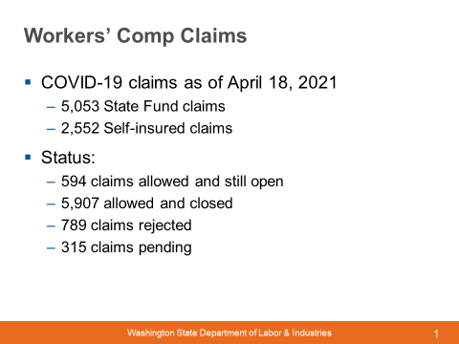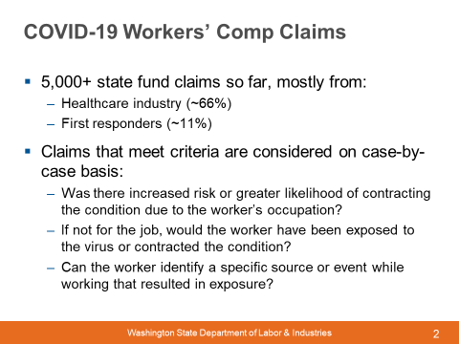

- Legislative – Kim Wallace
Hanford update
Kim shared about the work of the Hanford Healthy Energy Workers Board, including that there is a report due to the legislature in June. The report is likely to include recommendations on increasing access to care, promoting the quality of services, and improving coordination of care.
Bills
Kim summarized two bills that passed during the 2021 session related to presumptive benefits during a public health emergency – one focused on frontline workers; the other focused on health care employees. She also shared that a bill passed that allows L&I to make single lump sum payments under structured settlements which will prevent those workers who receive social security disability payments from experiencing reduced/offset benefits.
- New Interpreter Scheduling System – Karen Jost
The new system was launched April 12, 2021 and is available 24 hours a day, 7 days per week. Providers must register and request interpreters for all scheduled appointments through the InterpretingWorks online system. Interpreter agencies may no longer bill L&I. More information including FAQs are available at https://lni.wa.gov/patient-care/treating-patients/interpreter-services/.
- Next Subcommittee Discussion – Andrew Friedman
With the vote for the current guideline draft, please consider ideas for the next Subcommittee guideline topic.
*Actions taken or requested - None
^^Decisions made - None

Wrap Up

Planning for April meeting
Initial retreat ideas included onboarding topic, reviewing gathered information from the past regarding the committee’s mission, goals, and accomplishments.
*If you have not already done so, please share retreat ideas with the Chairs.
^^The decision was made to use part of one meeting in 2021 for a retreat; selection of topics will be discussed in July.
Meeting Adjourned @ 4:48 pm

