Elements for Becoming a VPP Site
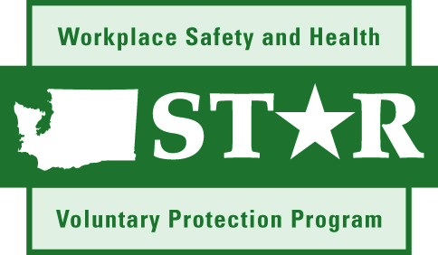

1. Management Commitment and Planning
Clearly established policies and procedures.
Goal-oriented objectives and accountability.
Resources (Safety & Health).

2. Accountability
Documented system for holding all line managers and supervisors accountable Safety & Health.

3. Disciplinary Program
Written Program that is communicated to ALL employees.
Covers both supervisors and their employees.

4. Injury Rates
Three-year average rate for both total recordable and days away/restricted work activity cases.

5. Employee Participation
Meaningful ways for employees to participate in the Safety & Health Program.

6. Self-Inspections
Monthly
-Cover entire worksite quarterly.
-Tracking of hazards to correction.

7. Employee Hazard Reporting System
Formal written reporting system.
Timely and appropriate responses.
Tracking of hazards to correction.

8. Accident/Incident Investigation
Written procedures.
Written reports of findings.
Tracking of hazards to correction.

9. JSA/Process Reviews
Analysis of hazards associated with individual jobs and processes.
Safety & Health training.
Tracking of hazards to correction.

10. Safety & Health Training
Supervisor training.
-Must understand hazards in their work areas.
Potential effects on their employees.
Ensure employees follow rules.
Employee training.
-Aware of hazards.
-Safety work procedures.
-Emergency situations.
-PPE use.

11. Preventive Maintenance
Written Preventive Maintenance Program.
Ongoing monitoring and maintenance of workplace equipment.

12. Emergency Programs/Drills
Written emergency program.
Drills for ALL employees.

13. Health Program
Baseline surveys.
Sampling, testing, and analysis with written records of results.
Tracking of hazards to correction.

14. Personal Protective Equipment
Appropriate PPE.
PPE training on care and use.
Replacement of PPE.

15. Safety & Health Staff Involved with Changes
Safety & Health staff must be involved with analysis of all new processes, materials, or equipment.
Safety & Health staff must be involved with any changes.

16. Contractor Safety
Selection criteria.
Training.
Enforcement.

17. Medical Program
Availability of physician services.
Personnel trained in First Aid/CPR.

18. Resources
Commitment of adequate Safety & Health staff.
Access to Safety Professionals and Industrial Hygienists.

19. Annual Evaluation
Must be in written narrative form.
Must have action dates.
Must cover all of the 19 program elements.
Must cover the status of the action dates from the prior year annual evaluation.

