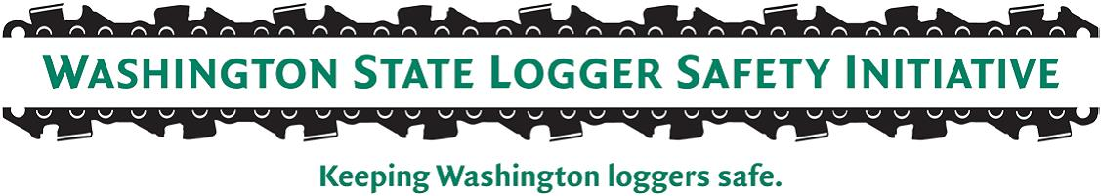
LSI Third-Party Audit on Oregon Worksites
LSI Companies with both Washington & Oregon jobs
In order to advance to Tier 3 of the Logger Safety Initiative Program (LSI), an employer must pass an independent third-party audit verifying compliance with the LSI safety requirements. Some companies, under the reciprocal agreement between Washington and Oregon, have temporary operations in Oregon.
As part of the third-party audit, the vendor (Site Response Inc.) will be required to audit all active manual logging operations, either in Washington or Oregon, in order to have a full view of the logging operations of the company.
Currently, there is no limit to the number of sites the third-party auditor will visit in order to conduct their audit; however, depending on future funding needs, this method will be evaluated.
Example: LSI Employer has two sides in Washington, and two sides in Oregon. The third-party auditor will visit all sides before completing the audit and granting a pass or fail determination into Tier 3.
LSI Companies with only Oregon jobs for more than 2-quarters
An LSI company is required to complete a DOSH comprehensive consultation before they are allowed to participate in a third-party audit (passing the third-party audit is required for a company to move to Tier 3 and earn an additional discount). However, DOSH Consultation is not able to travel to Oregon to conduct a comprehensive consultation. In cases where an LSI company is exclusively working in Oregon for more than 2 quarters (6 months or more), the following steps should be followed:
- Logging Company must meet all the other requirements of the program (technical premium audit, monthly supplemental reporting, etc).
- DOSH Consultation will do a review of the written APP, review the monthly safety inspections and other safety program requirements as identified.
- Logging Company will contact Oregon OSHA (OR-OSHA) Consultative Services (541-686-7913) and request a Comprehensive Safety Consultation. OR-OSHA Contact: Larry Fipps Consultation Services Manager.
  - Upon completion of the OR-OSHA comprehensive consultation visit the Logging company will request a copy of the entire consultation file. The Logging company will send a copy of the consultation file including their consultation findings to DOSH Consultation services (James Smith, 425-429-1573 or james.smith@lni.wa.gov)
- DOSH Consultation will review OR-OSHA consultation file to determine if the employer is following LSI requirements. DOSH Consultation will either pass or provide corrective actions based on their review of the written program and the OR- OSHA report. Once the company is “passed” by DOSH consultation, the company will be released to the third-party auditor for the independent safety audit. NOTE: the logging company may not be as prepared for the third-party audit by not having a comprehensive consultation by DOSH.

